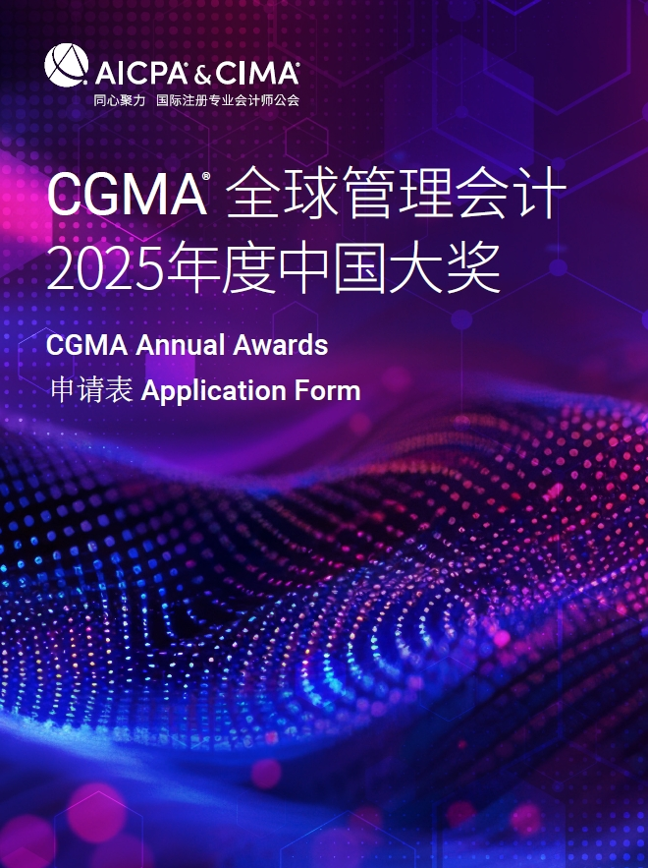

**Best Sustainability Award**

This award recognizes the leading companies that demonstrate outstanding vision and innovative practices in corporate operations and strategic management, and deeply embed the concept of sustainable development in financial decision-making and business transformation. The companies not only achieved steady growth in economic value, but also set industry benchmarks in environmental protection, social responsibility and corporate governance, leading future financial management in a greener, inclusive and sustainable direction, and jointly building a beautiful world of sustainable development.

**最佳可持续发展奖**

本奖项授予在企业运营与战略管理中，展现卓越远见与创新实践，将可持续发展理念深植于财务决策与业务转型之中的领先企业。获奖企业不仅实现了经济价值的稳健增长，更在环境保护、社会责任及公司治理方面树立了行业标杆，引领未来财务管理向更加绿色、包容、可持续的方向迈进。

**参赛规则**

1. Each entry can attach one relevant profile for judges’ reference.

每位参选人可提交一份附件供评委参考

2. Each entry must be submitted on a fully completed application form in both English and Chinese.

每位参选人必须提交一份完整的中英文申请表

3. The judges' decision will be final and no correspondence will be entered in the judging process.

评委会的决定为最终决定，在评委决定过程前后不得有任何通信联系

4. The application form should be submitted online by uploading at https://awards2025.cncima.com before the closing date of 10:00 (Beijing time) on 30th ,Sept, 2025. 申请表请于2025年9月30日上午10点（北京时间）之前通过 https://awards2025.cncima.com 点击“提交申请表单”完成提交。

AICPA & CIMA will not use any contents and materials you provided for commercial purposes, however, it might be cited or referred for internal publicity within our members and candidates to promote the success and achievements of digital management accounting in China.

Please choose from the following communication and publicity options that if you are not willing to share or exposure. (□ media release, □ interviews, □ marketing materials).

AICPA & CIMA (国际注册专业会计师公会) 不会将您提供的任何内容和材料用于商业目的，但可能会在我们的会员和候选人群体中进行宣传，以推广中国数字化管理会计的成功。

所述案例经严格筛选与评估，有可能将被纳入国际注册专业会计师公会的权威案例集之中，以供专业人士学习、研究与参考。（是否愿意： □是，□ 否）

请选择你不希望您的信息出现在以下哪类宣传资料中（ □新闻稿 □访谈 □市场推广资料）

**Declaration**

**申明**

I hereby certify that the information given in this entry form is correct and that I am willing to provide supporting documentation, if requested, to verify the information provided.

我在此申明所提供的信息都是准确的，如评委会需要，我可以提供相关的文档以供核实。

Name: Position:

姓名 职位

Signed: Date

签字 日期

**Application form**

**申请表**

|  |  |
| --- | --- |
| Company name  参评公司 |  |
| Contact person  联系人姓名 |  |
| Job title  联系人职位 |  |
| Phone No.  手机 |  |
| Email  邮箱 |  |
| Company Introduction & Key Performance (400 words in Chinese and the actual number of words in English)  公司简介及部门主要成就（中文400字，英文按实际字数） |  |

Note: Questions should be completed in no more than approximately 2000 words in Chinese and the actual number of words in English. Suggested format: Chinese - Microsoft Yahei, English -Arial, font 12, 1.5 line space.

温馨提示：

* 答题总字数2000字以内 ，英文按实际字数 (均须以中英文双语回答)
* 建议格式： 中文-微软雅黑 , 英文-Arial ，字号 12，1.5倍行距

1. Please outline your company's ESG integration strategy. How are ESG factors considered in your corporate strategy and daily operations? Can you elaborate on your process for identifying and prioritizing key ESG issues, and how these are translated into actionable plans?

请描述贵公司如何将ESG因素整合到企业战略和日常运营中。具体来说，贵公司是如何识别和优先考虑关键的ESG问题，并将这些问题转化为行动计划的？

2. Please describe your company's approach to ESG communication with stakeholders. How do you effectively convey your ESG goals and practices to investors, consumers, suppliers, and the community? Can you provide specific examples of how stakeholder engagement has contributed to the enhancement of your ESG performance?

贵公司是如何与投资者、消费者、供应商和社区等利益相关者就ESG目标和实践进行有效沟通的？请提供具体例证，说明这些互动如何帮助贵公司改进或加强其ESG绩效。

3. Please highlight one or more innovative ESG initiatives undertaken by your company. How have these projects contributed to environmental protection, social responsibility, or corporate governance? Can you quantify the positive outcomes of these initiatives?

请分享一个或多个贵公司在ESG方面的创新项目或实践，这些活动如何显著提升了环境保护、社会责任或公司治理？具体影响包括哪些可度量的成果？

4. What have been the most significant challenges your company has faced in your ESG journey? How has your company addressed these challenges through specific measures? Please describe the process and outcomes of these measures, as well as their long-term impact on the company's sustainable development.

在贵公司的ESG旅程中，遇到的最大挑战是什么？贵公司采取了哪些具体措施来应对这些挑战？请分享实施这些措施的过程和结果，以及对企业持续发展的长远影响。